VISVESVARAYA TECHNOLOGICAL UNIVERSITY
BELAGAVI-590014, KARNATAKA
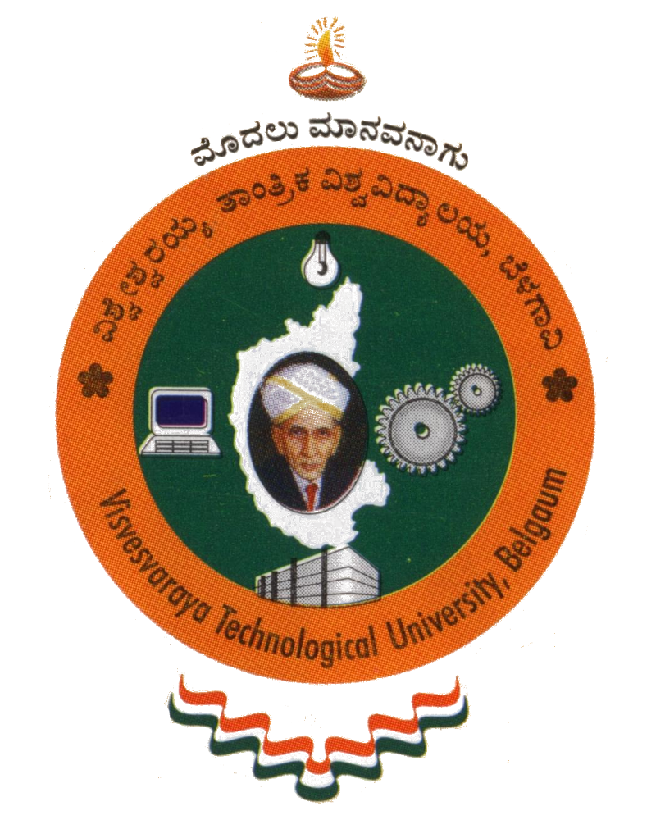
A Mini Project Report
On
“FOOTBALL MANAGEMENT SYSTEM”
Submitted in Partial Fulfillment of the Requirement for
“DBMS Laboratory with Mini Project -V Semester”
For the Award of Degree
BACHELOR OF ENGINEERING
IN
COMPUTER SCIENCE & ENGINEERING
Submitted By:
ABHINETRA KUMAR (1SG16CS001)
ADITYA DEEP (1SG16CS004)

Under the Guidance of:
Mrs. Kavya N L Mrs. Nanda M B
Assistant Professor Assistant Professor


Department of Computer Science and Engineering
SAPTHAGIRI COLLEGE OF ENGINEERING
14/5, Chikkasandra, Hesarghatta Main Road
Bengaluru - 560057

2018-2019

SAPTHAGIRI COLLEGE OF ENGINEERING
14/5, Chikkasandra, Hesaraghatta Main Road, Bengaluru – 560057.

Department of Computer Science and Engineering
Certificate
Certified that the Mini Project Work entitled “FOOTBALL MANAGEMENT SYSTEM” carried out by ABHINETRA KUMAR (1SG16CS001) & ADITYA DEEP (1SG16CS004), bonafide students of Sapthagiri College of Engineering, in partial fulfillment for the award of Bachelor of Engineering degree in Computer Science and Engineering of Visvesvaraya Technological University, Belagavi during the academic year 2018-2019. It is certified that all corrections/suggestions indicated for Internal Assessment have been incorporated in the report deposited in the department library. The mini project report has been approved as it satisfies the academic requirements in respect of DBMS Laboratory with Mini Project (15CSL58) prescribed for the said Degree.

Signature of the Guide Signature of the Guide Signature of the HOD
Mrs. Kavya N L Mrs. Nanda M B Dr. Yogish H K
Assistant Professor Assistant Professor Professor & Head

EXTERNAL EXAMINATION

Name of the Examiners Signature with Date

1.___________________________ _________________________

2.___________________________ _________________________

